**Flow to the Project (ChatBuddy)**

**Home**

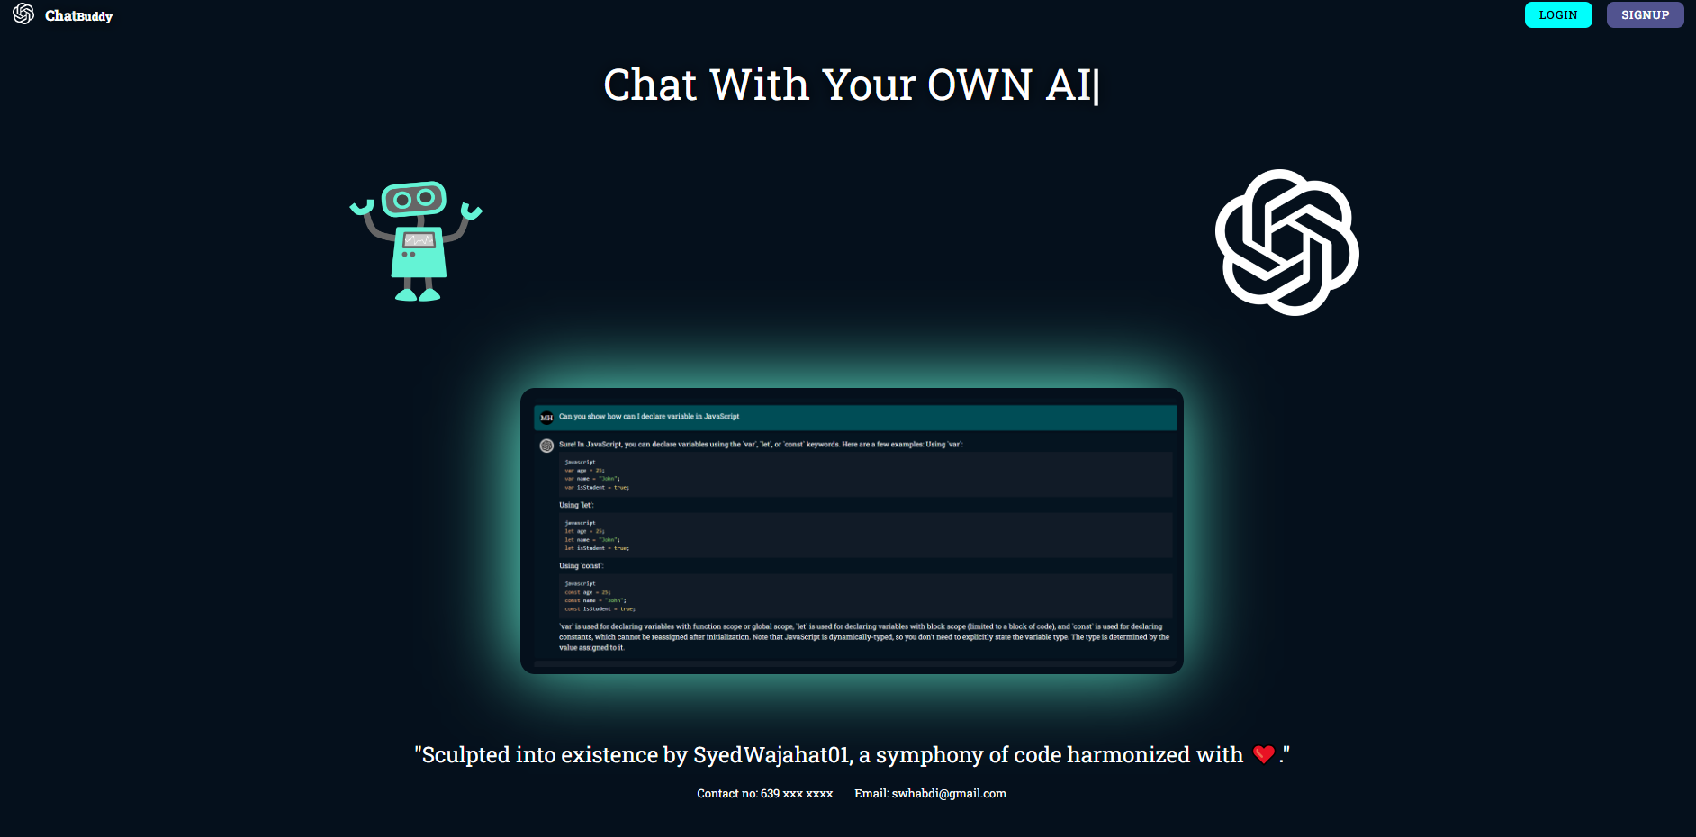

"Welcome to the heart of innovation! 🌐 Explore our ChatBot Project's home page, where cutting-edge AI meets seamless interaction. Dive into dynamic conversations, personalized responses, and a user-friendly interface. Experience the future of chat – intelligent, intuitive, and designed just for you! 🚀 #ChatBotInnovation #AIRevolution".

**Sign Up**

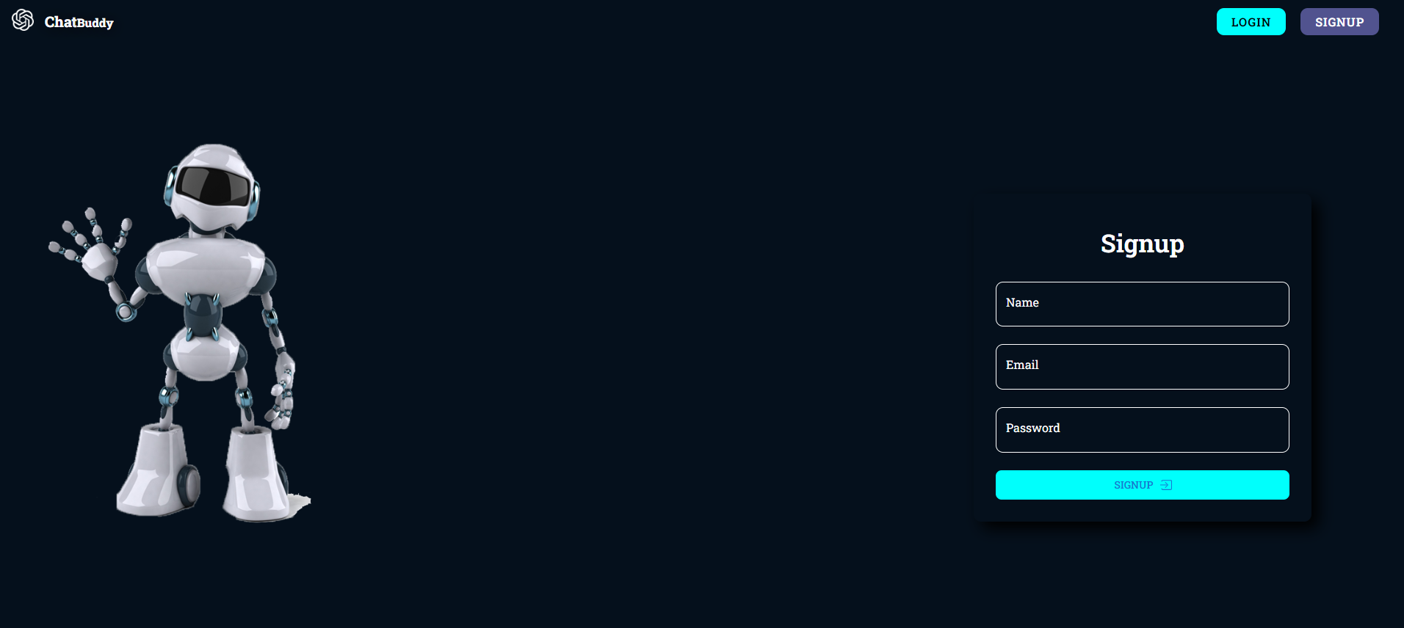

"Embark on a journey of intelligent conversations! 🌟 Join our ChatBot Project with a simple sign-up. Your gateway to personalized interactions, dynamic chats, and a future-driven experience. Sign up now and step into the world of AI innovation! 🚀🔐 #SignUpForAI #ChatBotRevolution"

**Login**

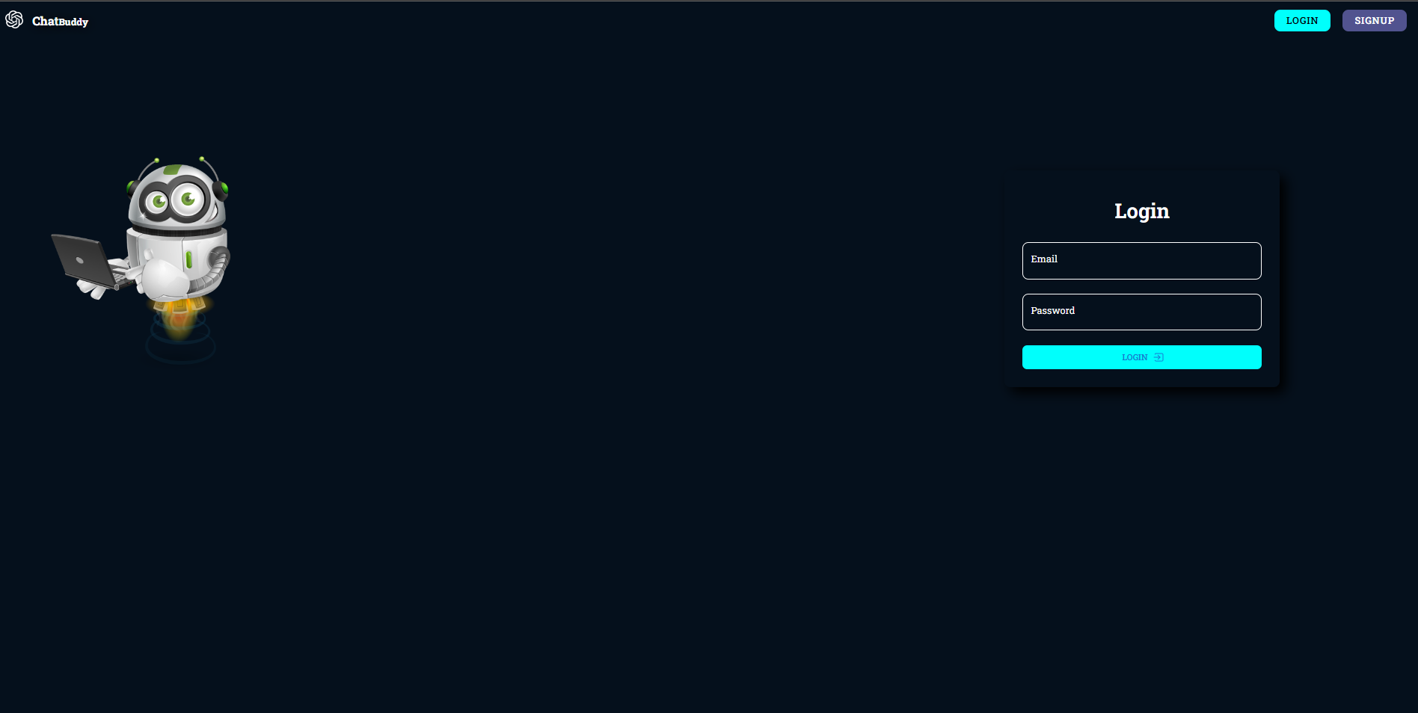

"Welcome to the heart of innovation! 🌐 Explore our ChatBot Project's home page, where cutting-edge AI meets seamless interaction. Dive into dynamic conversations, personalized responses, and a user-friendly interface. Experience the future of chat – intelligent, intuitive, and designed just for you! 🚀 #ChatBotInnovation #AIRevolution"

**Main Page**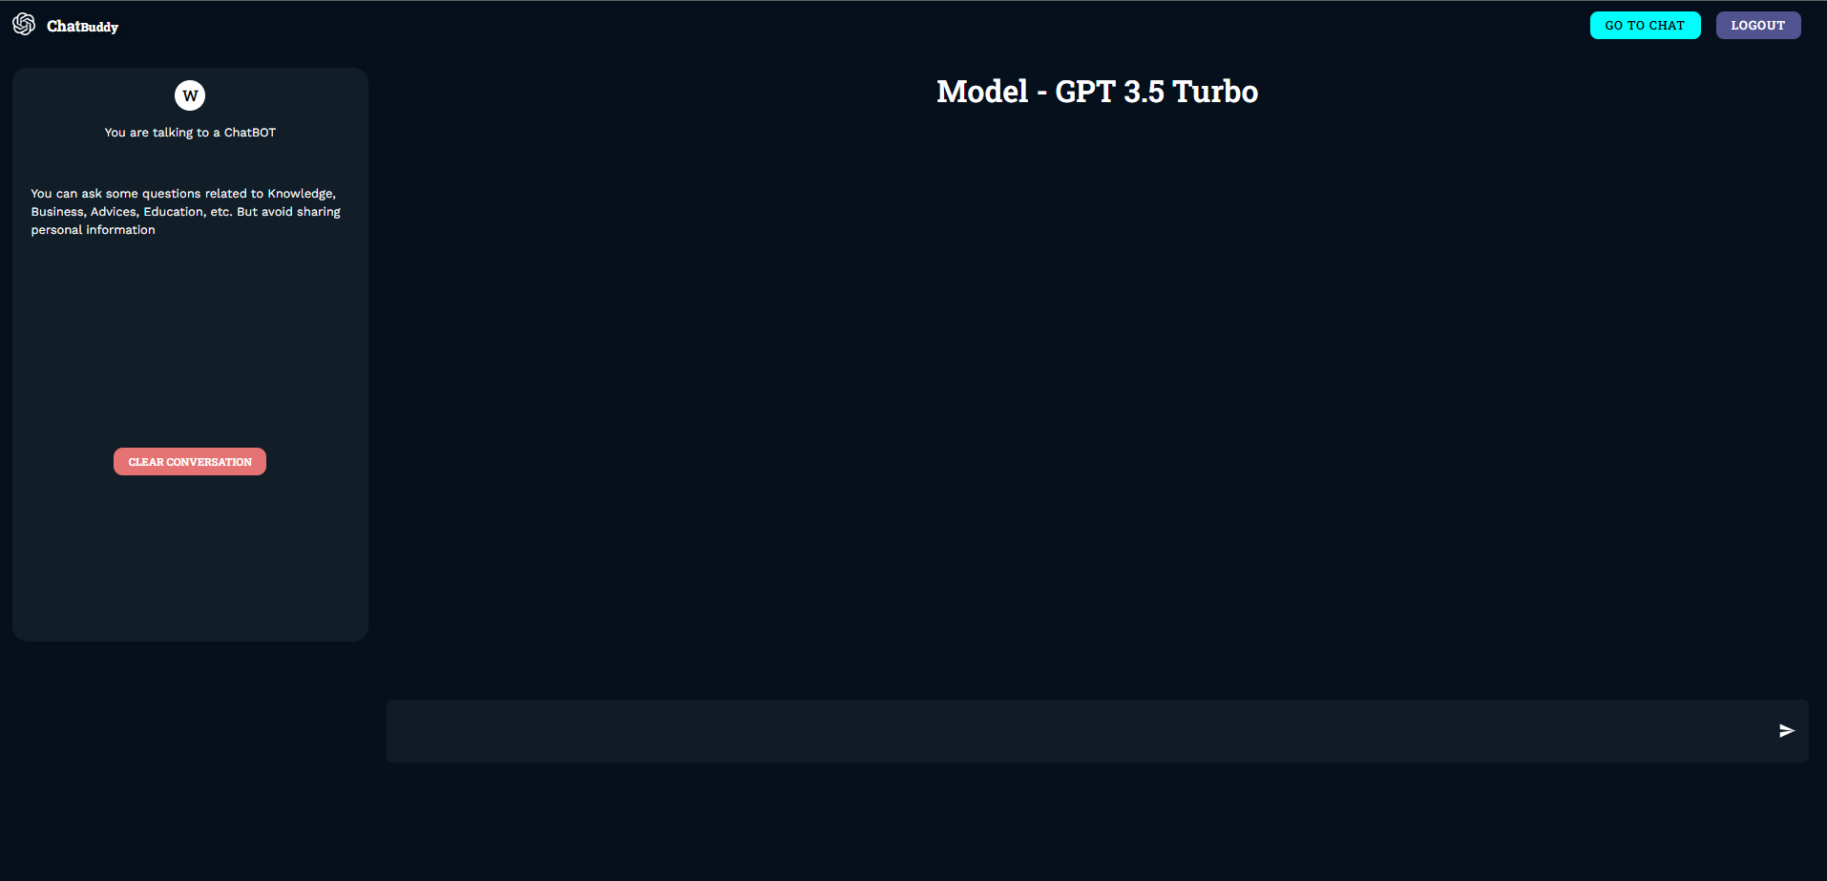

"Embark on a journey of intelligent conversations! 🌟 Join our ChatBot Project with a simple sign-up. Your gateway to personalized interactions, dynamic chats, and a future-driven experience. Sign up now and step into the world of AI innovation! 🚀🔐 #SignUpForAI #ChatBotRevolution"

**Get Desired Out.**

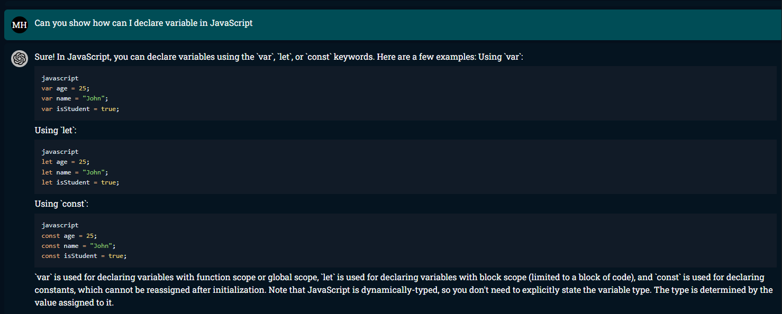

"Embark on a journey of intelligent conversations! 🌟 Join our ChatBot Project with a simple sign-up. Your gateway to personalized interactions, dynamic chats, and a future-driven experience. Sign up now and step into the world of AI innovation! 🚀🔐 #SignUpForAI #ChatBotRevolution"